Forms Experts Program

Domain Name: Named Non-Owner Coverage Endorsement

Document Control Information

Document Information

|  |  |
| --- | --- |
| Document Name | Forms Experts Output_Named Non-Owner Coverage Endorsement |
| Document Author | Saurabh Jain |
| Document Version | 1.0 |
| Date Released | 8/28/2013 |

Document Edit History

| Version | Date | Additions/Modifications | Prepared/Revised by |
| --- | --- | --- | --- |
| 1.0 | 8/28/2013 | Initial version | Saurabh Jain |
|  |  |  |  |
|  |  |  |  |
|  |  |  |  |

Table of Contents

1. Functional Domain 5

2. Business Justification 5

3. List of forms covered under the domain 6

4. Analysis of Business Requirements 6

4.1 Common Requirements 6

4.2 State-specific Requirements (if any) 6

4.3 Related Change Requests 8

5. Key Understanding of Design requirements, (form wise) 9

5.1 AA41MT Named Non-Owner Coverage Endorsement 9

5.1.1 System/UI Impact 9

5.1.2 Impacted Stories 9

5.1.3 Signature Rules(if any) 10

5.1.4 Document Content and Applicable Triggers 10

5.1.5 Any other crucial info worth mentioning, (if any) 10

5.2 AA41WY Named Non-Owner Coverage Endorsement 11

5.2.1 System/UI Impact 11

5.2.2 Impacted Stories 11

5.2.3 Signature Rules(if any) 12

5.2.4 Document Content and Applicable Triggers 12

5.2.5 Any other crucial info worth mentioning, (if any) 12

5.3 AA41PA Named Non-Owner Coverage Endorsement 13

5.3.1 System/UI Impact 13

5.3.2 Impacted Stories 13

5.3.3 Signature Rules(if any) 14

5.3.4 Document Content and Applicable Triggers 14

5.3.5 Any other crucial info worth mentioning, (if any) 14

5.4 AA41MD Named Non-Owner Coverage Endorsement 15

5.4.1 System/UI Impact 15

5.4.2 Impacted Stories 15

5.4.3 Signature Rules(if any) 16

5.4.4 Document Content and Applicable Triggers 16

5.4.5 Any other crucial info worth mentioning, (if any) 16

5.5 AA41PA Named Non-Owner Coverage Endorsement 17

5.5.1 System/UI Impact 17

5.5.2 Impacted Stories 17

5.5.3 Signature Rules(if any) 18

5.5.4 Document Content and Applicable Triggers 18

5.5.5 Any other crucial info worth mentioning, (if any) 18

5.6 AA41NJ Named Non-Owner Coverage Endorsement 19

5.6.1 System/UI Impact 19

5.6.2 Impacted Stories 19

5.6.3 Signature Rules(if any) 20

5.6.4 Document Content and Applicable Triggers 20

5.6.5 Any other crucial info worth mentioning, (if any) 20

5.7 AA41DE Named Non-Owner Coverage Endorsement 21

5.7.1 System/UI Impact 21

5.7.2 Impacted Stories 21

5.7.3 Signature Rules(if any) 21

5.7.4 Document Content and Applicable Triggers 22

5.7.5 Any other crucial info worth mentioning, (if any) 22

5.8 AA41CT Named Non-Owner Coverage Endorsement 23

5.8.1 System/UI Impact 23

5.8.2 Impacted Stories 23

5.8.3 Signature Rules(if any) 24

5.8.4 Document Content and Applicable Triggers 24

5.8.5 Any other crucial info worth mentioning, 24

5.9 AA41KY Named Non-Owner Coverage Endorsement 25

5.9.1 System/UI Impact 25

5.9.2 Impacted Stories 25

5.9.3 Signature Rules(if any) 26

5.9.4 Document Content and Applicable Triggers 26

5.9.5 Any other crucial info worth mentioning, 26

5.10 AA41DC Named Non-Owner Coverage Endorsement 27

5.10.1 System/UI Impact 27

5.10.2 Impacted Stories 27

5.10.3 Signature Rules(if any) 27

5.10.4 Document Content and Applicable Triggers 28

5.10.5 Any other crucial info worth mentioning, 28

5.11 AA41ID Named Non-Owner Coverage Endorsement 29

5.11.1 System/UI Impact 29

5.11.2 Impacted Stories 29

5.11.3 Signature Rules(if any) 29

5.11.4 Document Content and Applicable Triggers 30

5.11.5 Any other crucial info worth mentioning, 30

6. References to Documents 30

7. Reference Screenshots 31

1. Functional Domain

Named Non-Owner Coverage Endorsement

2. Business Justification

A Named Non-Owner policy provides minimum limits of liability protection only to an individual who does not own a vehicle or have access to any personal use vehicle on a regular basis. Coverage does not extend to any other vehicle owned by family members of the household in which the named insured resides or any other vehicles accessible to the named insured on a regular basis. Named Insured and spouse may be listed only; no other drivers (included “list” or “excluded”) allowed.

Coverage under a non-owners policy includes:

* Bodily injury liability
* Property damage liability

 The following coverages are also offered as part of a non-owners policy:

* Medical payments coverage
* Uninsured motorist bodily injury coverage
* Underinsured motorist bodily injury coverage

Because a car is not attached to a non-owners policy, the following coverage are NOT offered:

* Collision
* Comprehensive
* Rental reimbursement
* Towing and labor
* Custom parts and equipment coverage

Some examples wherin a Named Non owner policy is taken are as follows

* **Low-cost rental insurance –** Coverage can be used while taking vehicles on rent instead of paying the temporary insurance fee to the renter
* **Urban dwellers –** People who live in urban areas may go for this option since owning a vehicle is not necessary.Some of these are part-time drivers and need occasional insurance
* **Limited-time situations –** If someone is providing a lot of Valet service or delivering vehicles to auctions then they can go for this king of insurance.

A non-owners personal auto insurance policy isn't for you if:

* You own a car. In this case, purchase a standard owner's policy.
* There is a vehicle in your household. Normally, in this situation you would be required to be placed on the car owner's policy as a driver to be covered instead of obtaining a non-owners policy of your own. This is especially true if your spouse owns a vehicle, since an insurer may consider that vehicle your property to insure as well.
* You drive a car on a regular basis. If you don't own a car but drive someone else's on a frequent basis, you should be added to that person's policy as a driver or if in full possession of the vehicle find an insurer that will allow you to place a regular auto insurance policy on that vehicle.
* You are using a vehicle for business use. A commercial non-owners policy, offered by companies such as Progressive, may be better suited for this need.
* You don't have a driver's license and cannot obtain one within 30 days of starting a non-owners policy.

3. List of forms covered under the domain

| Form No. | State initials | Form Name |
| --- | --- | --- |
| AA41MT | MT | Named Non-Owner Coverage Endorsement |
| AA41WY | WY | Named Non-Owner Coverage Endorsement |
| AA41MD | MD | Named Non-Owner Coverage Endorsement |
| AA41PA | PA | Named Non-Owner Coverage Endorsement |
| AA41NJ | NJ | Named Non-Owner Coverage Endorsement |
| AA41DE | DE | Named Non-Owner Coverage Endorsement |
| AA41CT | CT | Named Non-Owner Coverage Endorsement |
| AA41KY | KY | Named Non-Owner Coverage Endorsement |
| AA41DC | DC | Named Non-Owner Coverage Endorsement |
| AA41ID | ID | Named Non-Owner Coverage Endorsement |

* 1. Analysis of Business Requirements

## Common Requirements

*N/A*

## State-specific Requirements (if any)

The form contains static text explaining about the definitions and the coverages provided in the NANO policy.In the header section policy details like Policy number,Effective date, Named Insured and Agent code are mentioned.The footer contains the form number , copyright text and page number

| Form No. | State initials | Form Name | Form Description and its Business Use |
| --- | --- | --- | --- |
| AA41MT | MT | Named Non-Owner Coverage Endorsement | * This document includes general descriptions of coverage provided for NANO policy for MT state * The form name is a delta from CL   The document is of 3 page |
| AA41WY | WY | Named Non-Owner Coverage Endorsement | * This document includes general descriptions of coverage provided for NANO policy for MT state * The form name is a delta from CL   The document is of 3 page |
| AA41MD | MD | Named Non-Owner Coverage Endorsement | * This document includes general descriptions of coverage provided for NANO policy for MD state * The form name is a delta from CL * The document is of 3 page |
| AA41PA | PA | Named Non-Owner Coverage Endorsement | * This document includes general descriptions of coverage provided for NANO policy for PA state * The form name is a delta from CL * The document is of 4 page |
| AA41NJ | NJ | Named Non-Owner Coverage Endorsement | * This document includes general descriptions of coverage provided for NANO policy for NJ state * The form name is a delta from CL * The document is of 3 page |
| AA41DE | DE | Named Non-Owner Coverage Endorsement | * This document includes general descriptions of coverage provided for NANO policy for DE state * The form name is a delta from CL * The document is of 4 page |
| AA41CT | CT | Named Non-Owner Coverage Endorsement | * This document includes general descriptions of coverage provided for NANO policy for CT state * The form name is a delta from CL * The document is of 3 page |
| AA41KY | KY | Named Non-Owner Coverage Endorsement | * This document includes general descriptions of coverage provided for NANO policy for KY state * The form name is a delta from CL * The document is of 4 page |
| AA41DC | DC | Named Non-Owner Coverage Endorsement | * This document includes general descriptions of coverage provided for NANO policy for DC state * The form name is a delta from CL * The document is of 3 page |
| AA41ID | ID | Named Non-Owner Coverage Endorsement | * This document includes general descriptions of coverage provided for NANO policy for ID state * The form name is a delta from CL * The document is of 3 page |

## Related Change Requests

| CR No. | CR Name | States Impacted | CR Description and its Business Use |
| --- | --- | --- | --- |
| CR0399 | Named Non-owner Endt text change | MT | * The footer text change was implemented as part of this Change request * Year 2009 was changed to 2003 in the footer text |
| CR 0470 | Template text change | NJ | * Static text change to middle of form * There are changes in two sections of the static text that require DCS change.   - I. Definitions, section C, Point 2:  - II. Part I - Liability Coverage section A, Point 2 |

* 1. **References to Documents**

[880-086CL - NANO Form - Document Content](https://ekm1.stage.exigengroup.com/EKMWiki/index.php/880-086CL_-_NANO_Form_-_Document_Content)

* 1. Key Understanding of Design requirements, (form wise)

## AA41MT Named Non-Owner Coverage Endorsement

### System/UI Impact

| Page | Yes/No | Page Section |
| --- | --- | --- |
| Forms | | Yes | Policy Forms section | |
| Documents | | No | N/A | |
| GODD | | No | N/A | |
| Related UW Rule/Task | | No | N/A | |

### Impacted Stories

| Type | Story # *(enter story # or N/A if form doesn’t require update to state specific story. Any legacy EKM story #s within the listed combo templates should be included in the story writing analysis)* |
| --- | --- |
| Form Content & Triggers | 880-086MT NANO Form - Document Content |
| Documents Page | N/A |
| GODD Page | N/A |
| Forms Page | 880-820MT Consolidated Form Stories - Forms Page   * 070-245MT - Policy Rules * 070-247MT - Forms Page - NANO Forms |
| RFI | N/A |
| Packet/Print Story | 880-880MT Consolidated Form Stories - PRINTED Forms - Packets – Sequence   * 880-239MT - New Business * 880-199MT- Endorsement |

### Signature Rules(if any)

* N/A

### Document Content and Applicable Triggers

* **@Bind** – Document is not generated at Bind
* **@ New Business**

- If policy vehicle type is equal to “named non-owner” system form is generated as part of New Business Packet when applicable.

- Form number prints on DEC page in FORMS & ENDORSEMENT section

* **@Amendment**

- If policy is endorsed via a mid-term transaction **to be** policy type “named non-owner” then system generate form as part of the Amended DEC packet

- Form number prints on Amended DEC in the FORMS & ENDORSEMENT section

* **@Renewal**

- If policy type is “named non-owner” at time of renewal offer form number must print on the Renewal DEC page in the FORMS & ENDORSEMENT section

- Form **does not** regenerate as part of the renewal offer packet

* **Document Content**

- The Header section of the form containspolicy details like Policy Number, Effective Date, Named Insured, Agent Code

- The document body contain the title followed by the description of the coverage provided by the policy

- The footer contains Form name along with edition date and copyright text

### Any other crucial info worth mentioning, (if any)

* Vehicles cannot be added in a NANO policy
* If at Endorsement a policy is changed from Standard to NANO then all the vehicles are removed from the policy
* Only Spouse can be selected for the second driver/insured for NANO policy
  + 1. **References to Documents**

**Form Templates and US/VC documents:**

[AA41MT 01 13](https://ekm1.stage.exigengroup.com/EKMWiki/index.php/880-086MT_NANO_Form_-_Document_Content)

**Form Assessments:**

N/A

## AA41WY Named Non-Owner Coverage Endorsement

### System/UI Impact

| Page | Yes/No | Page Section |
| --- | --- | --- |
| Forms | | Yes | Policy Forms section | |
| Documents | | No | N/A | |
| GODD | | No | N/A | |
| Related UW Rule/Task | | No | N/A | |

### Impacted Stories

| Type | Story # *(enter story # or N/A if form doesn’t require update to state specific story. Any legacy EKM story #s within the listed combo templates should be included in the story writing analysis)* |
| --- | --- |
| Form Content & Triggers | 880-086WY NANO Form - Document Content |
| Documents Page | N/A |
| GODD Page | N/A |
| Forms Page | 880-820WY Consolidated Form Stories - Forms Page   * 070-245WY - Policy Rules * 070-247WY - Forms Page - NANO Forms |
| RFI | N/A |
| Packet/Print Story | 880-880MT Consolidated Form Stories - PRINTED Forms - Packets – Sequence   * 880-239WY - New Business * 880-199WY- Endorsement |

### Signature Rules(if any)

* N/A

### Document Content and Applicable Triggers

* **@Bind** – Document is not generated at Bind
* **@ New Business**

- If policy vehicle type is equal to “named non-owner” system form is generated as part of New Business Packet when applicable.

- Form number prints on DEC page in FORMS & ENDORSEMENT section

* **@Amendment**

- If policy is endorsed via a mid-term transaction **to be** policy type “named non-owner” then system generate form as part of the Amended DEC packet

- Form number prints on Amended DEC in the FORMS & ENDORSEMENT section

* **@Renewal**

- If policy type is “named non-owner” at time of renewal offer form number must print on the Renewal DEC page in the FORMS & ENDORSEMENT section

- Form **does not** regenerate as part of the renewal offer packet

* **Document Content**

- The Header section of the form containspolicy details like Policy Number, Effective Date, Named Insured, Agent Code

- The document body contain the title followed by the description of the coverage provided by the policy

- The footer contains Form name along with edition date and copyright text

### Any other crucial info worth mentioning, (if any)

* Vehicles cannot be added in a NANO policy
* If at Endorsement a policy is changed from Standard to NANO then all the vehicles are removed from the policy
* Only Spouse can be selected for the second driver/insured for NANO policy
  + 1. **References to Documents**

**Form Templates and US/VC documents:**

[AA41WY 01 13](https://ekm1.stage.exigengroup.com/EKMWiki/index.php/880-086WY_-_NANO_Form_-_Document_Content)

**Form Assessments:**

N/A

## AA41PA Named Non-Owner Coverage Endorsement

### System/UI Impact

| Page | Yes/No | Page Section |
| --- | --- | --- |
| Forms | | Yes | Policy Forms section | |
| Documents | | No | N/A | |
| GODD | | No | N/A | |
| Related UW Rule/Task | | No | N/A | |

### Impacted Stories

| Type | Story # *(enter story # or N/A if form doesn’t require update to state specific story. Any legacy EKM story #s within the listed combo templates should be included in the story writing analysis)* |
| --- | --- |
| Form Content & Triggers | 880-086PA NANO Form - Document Content |
| Documents Page | N/A |
| GODD Page | N/A |
| Forms Page | 880-820PA Consolidated Form Stories - Forms Page   * 070-245PA - Policy Rules * 070-247PA - Forms Page - NANO Forms |
| RFI | N/A |
| Packet/Print Story | 880-880PA Consolidated Form Stories - PRINTED Forms - Packets – Sequence   * 880-239PA - New Business * 880-199PA- Endorsement |

### Signature Rules(if any)

* N/A

### Document Content and Applicable Triggers

* **@Bind** – Document is not generated at Bind
* **@ New Business**

- If policy vehicle type is equal to “named non-owner” system form is generated as part of New Business Packet when applicable.

- Form number prints on DEC page in FORMS & ENDORSEMENT section

* **@Amendment**

- If policy is endorsed via a mid-term transaction **to be** policy type “named non-owner” then system generate form as part of the Amended DEC packet

- Form number prints on Amended DEC in the FORMS & ENDORSEMENT section

* **@Renewal**

- If policy type is “named non-owner” at time of renewal offer form number must print on the Renewal DEC page in the FORMS & ENDORSEMENT section

- Form **does not** regenerate as part of the renewal offer packet

* **Document Content**

- The Header section of the form containspolicy details like Policy Number, Effective Date, Named Insured, Agent Code

- The document body contain the title followed by the description of the coverage provided by the policy

- The footer contains Form name along with edition date, copyright text and Page number

### Any other crucial info worth mentioning, (if any)

* Vehicles cannot be added in a NANO policy
* If at Endorsement a policy is changed from Standard to NANO then all the vehicles are removed from the policy
* Only Spouse can be selected for the second driver/insured for NANO policy
  + 1. **References to Documents**

**Form Templates and US/VC documents:**

[AA41PA 01 13](https://ekm1.stage.exigengroup.com/EKMWiki/index.php/880-086PA_-_NANO_Form_-_Document_Content)

**Form Assessments:**

N/A

## AA41MD Named Non-Owner Coverage Endorsement

### System/UI Impact

| Page | Yes/No | Page Section |
| --- | --- | --- |
| Forms | | Yes | Policy Forms section | |
| Documents | | No | N/A | |
| GODD | | No | N/A | |
| Related UW Rule/Task | | No | N/A | |

### Impacted Stories

| Type | Story # *(enter story # or N/A if form doesn’t require update to state specific story. Any legacy EKM story #s within the listed combo templates should be included in the story writing analysis)* |
| --- | --- |
| Form Content & Triggers | 880-086MD NANO Form - Document Content |
| Documents Page | N/A |
| GODD Page | N/A |
| Forms Page | 880-820MD Consolidated Form Stories - Forms Page   * 070-245MD - Policy Rules * 070-247MD - Forms Page - NANO Forms |
| RFI | N/A |
| Packet/Print Story | 880-880MD Consolidated Form Stories - PRINTED Forms - Packets – Sequence   * 880-239MD - New Business * 880-199MD- Endorsement |

### Signature Rules(if any)

* N/A

### Document Content and Applicable Triggers

* **@Bind** – Document is not generated at Bind
* **@ New Business**

- If policy vehicle type is equal to “named non-owner” system form is generated as part of New Business Packet when applicable.

- Form number prints on DEC page in FORMS & ENDORSEMENT section

* **@Amendment**

- If policy is endorsed via a mid-term transaction **to be** policy type “named non-owner” then system generate form as part of the Amended DEC packet

- Form number prints on Amended DEC in the FORMS & ENDORSEMENT section

* **@Renewal**

- If policy type is “named non-owner” at time of renewal offer form number must print on the Renewal DEC page in the FORMS & ENDORSEMENT section

- Form **does not** regenerate as part of the renewal offer packet

* **Document Content**

- The Header section of the form containspolicy details like Policy Number, Effective Date, Named Insured, Agent Code

- The document body contain the title followed by the description of the coverage provided by the policy

- The footer contains Form name along with edition date, copyright text and Page number

### Any other crucial info worth mentioning, (if any)

* Vehicles cannot be added in a NANO policy
* If at Endorsement a policy is changed from Standard to NANO then all the vehicles are removed from the policy
* Only Spouse can be selected for the second driver/insured for NANO policy
  + 1. **References to Documents**

**Form Templates and US/VC documents:**

[AA41MD 03 13](https://ekm1.stage.exigengroup.com/EKMWiki/index.php/880-086MD_-_NANO_Form_-_Document_Content)

**Form Assessments:**

[MDF04 AA41MD0313 Named Non Owner](https://ekm1.stage.exigengroup.com/EKMWiki/index.php/MDF04_AA41MD0313_Named_Non_Owner)

## AA41PA Named Non-Owner Coverage Endorsement

### System/UI Impact

| Page | Yes/No | Page Section |
| --- | --- | --- |
| Forms | | Yes | Policy Forms section | |
| Documents | | No | N/A | |
| GODD | | No | N/A | |
| Related UW Rule/Task | | No | N/A | |

### Impacted Stories

| Type | Story # *(enter story # or N/A if form doesn’t require update to state specific story. Any legacy EKM story #s within the listed combo templates should be included in the story writing analysis)* |
| --- | --- |
| Form Content & Triggers | 880-086PA NANO Form - Document Content |
| Documents Page | N/A |
| GODD Page | N/A |
| Forms Page | 880-820MD Consolidated Form Stories - Forms Page   * 070-245PA - Policy Rules * 070-247PA - Forms Page - NANO Forms |
| RFI | N/A |
| Packet/Print Story | 880-880PA Consolidated Form Stories - PRINTED Forms - Packets – Sequence   * 880-239PA - New Business * 880-199PA- Endorsement |

### Signature Rules(if any)

* N/A

### Document Content and Applicable Triggers

* **@Bind** – Document is not generated at Bind
* **@ New Business**

- If policy vehicle type is equal to “named non-owner” system form is generated as part of New Business Packet when applicable.

- Form number prints on DEC page in FORMS & ENDORSEMENT section

* **@Amendment**

- If policy is endorsed via a mid-term transaction **to be** policy type “named non-owner” then system generate form as part of the Amended DEC packet

- Form number prints on Amended DEC in the FORMS & ENDORSEMENT section

* **@Renewal**

- If policy type is “named non-owner” at time of renewal offer form number must print on the Renewal DEC page in the FORMS & ENDORSEMENT section

- Form **does not** regenerate as part of the renewal offer packet

* **Document Content**

- The Header section of the form containspolicy details like Policy Number, Effective Date, Named Insured, Agent Code

- The document body contain the title followed by the description of the coverage provided by the policy

- The footer contains Form name along with edition date, copyright text and Page number

### Any other crucial info worth mentioning, (if any)

* Vehicles cannot be added in a NANO policy
* If at Endorsement a policy is changed from Standard to NANO then all the vehicles are removed from the policy
* Only Spouse can be selected for the second driver/insured for NANO policy
  + 1. **References to Documents**

**Form Templates and US/VC documents:**

[AA41PA 01 13](https://ekm1.stage.exigengroup.com/EKMWiki/index.php/880-086PA_-_NANO_Form_-_Document_Content)

**Form Assessments:**

N/A

## AA41NJ Named Non-Owner Coverage Endorsement

### System/UI Impact

| Page | Yes/No | Page Section |
| --- | --- | --- |
| Forms | | Yes | Policy Forms section | |
| Documents | | No | N/A | |
| GODD | | No | N/A | |
| Related UW Rule/Task | | No | N/A | |

### Impacted Stories

| Type | Story # *(enter story # or N/A if form doesn’t require update to state specific story. Any legacy EKM story #s within the listed combo templates should be included in the story writing analysis)* |
| --- | --- |
| Form Content & Triggers | 880-086NJ - Form Content and Triggers - Named NonOwner Coverage Endorsement AA41NJ |
| Documents Page | N/A |
| GODD Page | N/A |
| Forms Page | 880-820NJ Consolidated Form Stories - Forms Page   * 070-245NJ - Policy Rules * 070-247NJ - Forms Page - NANO Forms |
| RFI | N/A |
| Packet/Print Story | 880-880NJ Consolidated Form Stories - PRINTED Forms - Packets – Sequence   * 880-239NJ - New Business * 880-199NJ- Endorsement |

### Signature Rules(if any)

* N/A

### Document Content and Applicable Triggers

* **@Bind** – Document is not generated at Bind
* **@ New Business**

- If policy vehicle type is equal to “named non-owner” system form is generated as part of New Business Packet when applicable.

- Form number prints on DEC page in FORMS & ENDORSEMENT section

* **@Amendment**

- If policy is endorsed via a mid-term transaction **to be** policy type “named non-owner” then system generate form as part of the Amended DEC packet

- Form number prints on Amended DEC in the FORMS & ENDORSEMENT section

* **@Renewal**

- If policy type is “named non-owner” at time of renewal offer form number must print on the Renewal DEC page in the FORMS & ENDORSEMENT section

- Form **does not** regenerate as part of the renewal offer packet

* **Document Content**

- The Header section of the form containspolicy details like Policy Number, Effective Date, Named Insured, Agent Code

- The document body contain the title followed by the description of the coverage provided by the policy

- The footer contains Form name along with edition date, copyright text and Page number

### Any other crucial info worth mentioning, (if any)

* Vehicles cannot be added in a NANO policy
* If at Endorsement a policy is changed from Standard to NANO then all the vehicles are removed from the policy
* Only Spouse can be selected for the second driver/insured for NANO policy
  + 1. **References to Documents**

**Form Templates and US/VC documents:**

[AA41NJ 07 13](https://ekm1.stage.exigengroup.com/EKMWiki/index.php/880-086NJ_-_Form_Content_and_Triggers_-_Named_NonOwner_Coverage_Endorsement_AA41NJ)

**Form Assessments:**

[NJF02 AA41NJ Named Non Owner Coverage Endorsement](https://ekm1.stage.exigengroup.com/EKMWiki/index.php/NJF02_AA41NJ_Named_Non_Owner_Coverage_Endorsement)

## AA41DE Named Non-Owner Coverage Endorsement

### System/UI Impact

| Page | Yes/No | Page Section |
| --- | --- | --- |
| Forms | | Yes | Policy Forms section | |
| Documents | | No | N/A | |
| GODD | | No | N/A | |
| Related UW Rule/Task | | No | N/A | |

### Impacted Stories

| Type | Story # *(enter story # or N/A if form doesn’t require update to state specific story. Any legacy EKM story #s within the listed combo templates should be included in the story writing analysis)* |
| --- | --- |
| Form Content & Triggers | 880-086DE - Form Content and Triggers - Named NonOwner Coverage Endorsement AA41DE |
| Documents Page | N/A |
| GODD Page | N/A |
| Forms Page | 880-820DE Consolidated Form Stories - Forms Page   * 070-245DE - Policy Rules * 070-247DE - Forms Page - NANO Forms |
| RFI | N/A |
| Packet/Print Story | 880-880DE Consolidated Form Stories - PRINTED Forms - Packets – Sequence   * 880-239DE - New Business * 880-199DE- Endorsement |

### Signature Rules(if any)

* N/A

### Document Content and Applicable Triggers

* **@Bind** – Document is not generated at Bind
* **@ New Business**

- If policy vehicle type is equal to “named non-owner” system form is generated as part of New Business Packet when applicable.

- Form number prints on DEC page in FORMS & ENDORSEMENT section

* **@Amendment**

- If policy is endorsed via a mid-term transaction **to be** policy type “named non-owner” then system generate form as part of the Amended DEC packet

- Form number prints on Amended DEC in the FORMS & ENDORSEMENT section

* **@Renewal**

- If policy type is “named non-owner” at time of renewal offer form number must print on the Renewal DEC page in the FORMS & ENDORSEMENT section

- Form **does not** regenerate as part of the renewal offer packet

* **Document Content**

- The Header section of the form containspolicy details like Policy Number, Effective Date, Named Insured, Agent Code

- The document body contain the title followed by the description of the coverage provided by the policy

- The footer contains Form name along with edition date, copyright text and Page number

### Any other crucial info worth mentioning, (if any)

* Vehicles cannot be added in a NANO policy
* If at Endorsement a policy is changed from Standard to NANO then all the vehicles are removed from the policy
* Only Spouse can be selected for the second driver/insured for NANO policy
  + 1. **References to Documents**

**Form Templates and US/VC documents:**

[AA41DE 01 14](https://ekm1.stage.exigengroup.com/EKMWiki/index.php/880-086DE_-_NANO_Form_-_Document_Content)

**Form Assessments:**

[DEF16 AA41DE NAMED NON-OWNER COVERAGE ENDORSEMENT](https://ekm1.stage.exigengroup.com/EKMWiki/index.php/DEF16_AA41DE_NAMED_NON-OWNER_COVERAGE_ENDORSEMENT)

## AA41CT Named Non-Owner Coverage Endorsement

### System/UI Impact

| Page | Yes/No | Page Section |
| --- | --- | --- |
| Forms | | Yes | Policy Forms section | |
| Documents | | No | N/A | |
| GODD | | No | N/A | |
| Related UW Rule/Task | | No | N/A | |

### Impacted Stories

| Type | Story # *(enter story # or N/A if form doesn’t require update to state specific story. Any legacy EKM story #s within the listed combo templates should be included in the story writing analysis)* |
| --- | --- |
| Form Content & Triggers | 880-086CT - Form Content and Triggers - Named NonOwner Coverage Endorsement AA41CT |
| Documents Page | N/A |
| GODD Page | N/A |
| Forms Page | 880-820CT Consolidated Form Stories - Forms Page   * 070-245CT - Policy Rules * 070-247CT - Forms Page - NANO Forms |
| RFI | N/A |
| Packet/Print Story | 880-880CT Consolidated Form Stories - PRINTED Forms - Packets – Sequence   * 880-239CT - New Business * 880-199CT- Endorsement |

### Signature Rules(if any)

* N/A

### Document Content and Applicable Triggers

* **@Bind** – Document is not generated at Bind
* **@ New Business**

- If policy vehicle type is equal to “named non-owner” system form is generated as part of New Business Packet when applicable.

- Form number prints on DEC page in FORMS & ENDORSEMENT section

* **@Amendment**

- If policy is endorsed via a mid-term transaction **to be** policy type “named non-owner” then system generate form as part of the Amended DEC packet

- Form number prints on Amended DEC in the FORMS & ENDORSEMENT section

* **@Renewal**

- If policy type is “named non-owner” at time of renewal offer form number must print on the Renewal DEC page in the FORMS & ENDORSEMENT section

- Form **does not** regenerate as part of the renewal offer packet

* **Document Content**

- The Header section of the form containspolicy details like Policy Number, Effective Date, Named Insured, Agent Code

- The document body contain the title followed by the description of the coverage provided by the policy

- The footer contains Form name along with edition date, copyright text and Page number

### Any other crucial info worth mentioning,

* Vehicles cannot be added in a NANO policy
* If at Endorsement a policy is changed from Standard to NANO then all the vehicles are removed from the policy
* Only Spouse can be selected for the second driver/insured for NANO policy
  + 1. **References to Documents**

**Form Templates and US/VC documents:**

[AA41CT 01 14](https://ekm1.stage.exigengroup.com/EKMWiki/index.php/880-086CT_-_NANO_Form_-_Document_Content)

**Form Assessments:**

[CTF04 AA41CT NAMED NON-OWNER COVERAGE ENDORSEMENT](https://ekm1.stage.exigengroup.com/EKMWiki/index.php/CTF04_AA41CT_NAMED_NON-OWNER_COVERAGE_ENDORSEMENT)

## AA41KY Named Non-Owner Coverage Endorsement

### System/UI Impact

| Page | Yes/No | Page Section |
| --- | --- | --- |
| Forms | | Yes | Policy Forms section | |
| Documents | | No | N/A | |
| GODD | | No | N/A | |
| Related UW Rule/Task | | No | N/A | |

### Impacted Stories

| Type | Story # *(enter story # or N/A if form doesn’t require update to state specific story. Any legacy EKM story #s within the listed combo templates should be included in the story writing analysis)* |
| --- | --- |
| Form Content & Triggers | 880-086KY - NANO Form - Document Content |
| Documents Page | N/A |
| GODD Page | N/A |
| Forms Page | 880-820KY Consolidated Form Stories - Forms Page   * 070-245KY - Policy Rules * 070-247KY - Forms Page - NANO Forms |
| RFI | N/A |
| Packet/Print Story | 880-880KY Consolidated Form Stories - PRINTED Forms - Packets – Sequence   * 880-239KY - New Business * 880-199KY- Endorsement |

### Signature Rules(if any)

* N/A

### Document Content and Applicable Triggers

* **@Bind** – Document is not generated at Bind
* **@ New Business**

- If policy vehicle type is equal to “named non-owner” system form is generated as part of New Business Packet when applicable.

- Form number prints on DEC page in FORMS & ENDORSEMENT section

* **@Amendment**

- If policy is endorsed via a mid-term transaction **to be** policy type “named non-owner” then system generate form as part of the Amended DEC packet

- Form number prints on Amended DEC in the FORMS & ENDORSEMENT section

* **@Renewal**

- If policy type is “named non-owner” at time of renewal offer form number must print on the Renewal DEC page in the FORMS & ENDORSEMENT section

- Form **does not** regenerate as part of the renewal offer packet

* **Document Content**

- The Header section of the form containspolicy details like Policy Number, Effective Date, Named Insured, Agent Code

- The document body contain the title followed by the description of the coverage provided by the policy

- The footer contains Form name along with edition date, copyright text and Page number

### Any other crucial info worth mentioning,

* Vehicles cannot be added in a NANO policy
* If at Endorsement a policy is changed from Standard to NANO then all the vehicles are removed from the policy
* Only Spouse can be selected for the second driver/insured for NANO policy
  + 1. **References to Documents**

**Form Templates and US/VC documents:**

[AA41KY 02 14](https://ekm1.stage.exigengroup.com/EKMWiki/index.php/880-086KY_-_NANO_Form_-_Document_Content)

**Form Assessments:**

[KYF07 AA41KY NAMED NON-OWNER COVERAGE ENDORSEMENT](https://ekm1.stage.exigengroup.com/EKMWiki/index.php/KYF07_AA41KY_NAMED_NON-OWNER_COVERAGE_ENDORSEMENT)

## AA41DC Named Non-Owner Coverage Endorsement

### System/UI Impact

| Page | Yes/No | Page Section |
| --- | --- | --- |
| Forms | | Yes | Policy Forms section | |
| Documents | | No | N/A | |
| GODD | | No | N/A | |
| Related UW Rule/Task | | No | N/A | |

### Impacted Stories

| Type | Story # *(enter story # or N/A if form doesn’t require update to state specific story. Any legacy EKM story #s within the listed combo templates should be included in the story writing analysis)* |
| --- | --- |
| Form Content & Triggers | 880-086DC - NANO Form - Document Content |
| Documents Page | N/A |
| GODD Page | N/A |
| Forms Page | 880-820DC Consolidated Form Stories - Forms Page   * 070-245DC - Policy Rules * 070-247DC - Forms Page - NANO Forms |
| RFI | N/A |
| Packet/Print Story | 880-880DC Consolidated Form Stories - PRINTED Forms - Packets – Sequence   * 880-239DC - New Business * 880-199DC- Endorsement |

### Signature Rules(if any)

* N/A

### Document Content and Applicable Triggers

* **@Bind** – Document is not generated at Bind
* **@ New Business**

- If policy vehicle type is equal to “named non-owner” system form is generated as part of New Business Packet when applicable.

- Form number prints on DEC page in FORMS & ENDORSEMENT section

* **@Amendment**

- If policy is endorsed via a mid-term transaction **to be** policy type “named non-owner” then system generate form as part of the Amended DEC packet

- Form number prints on Amended DEC in the FORMS & ENDORSEMENT section

* **@Renewal**

- If policy type is “named non-owner” at time of renewal offer form number must print on the Renewal DEC page in the FORMS & ENDORSEMENT section

- Form **does not** regenerate as part of the renewal offer packet

* **Document Content**

- The Header section of the form containspolicy details like Policy Number, Effective Date, Named Insured, Agent Code

- The document body contain the title followed by the description of the coverage provided by the policy

- The footer contains Form name along with edition date, copyright text and Page number

### Any other crucial info worth mentioning,

* Vehicles cannot be added in a NANO policy
* If at Endorsement a policy is changed from Standard to NANO then all the vehicles are removed from the policy
* Only Spouse can be selected for the second driver/insured for NANO policy
  + 1. **References to Documents**

**Form Templates and US/VC documents:**

[AA41DC 02 14](https://ekm1.stage.exigengroup.com/EKMWiki/index.php/880-086DC_-_NANO_Form_-_Document_Content)

**Form Assessments:**

[DCF04 AA41DC NAMED NON-OWNER COVERAGE ENDORSEMENT](https://ekm1.stage.exigengroup.com/EKMWiki/index.php/DCF04_AA41DC_NAMED_NON-OWNER_COVERAGE_ENDORSEMENT)

## AA41ID Named Non-Owner Coverage Endorsement

### System/UI Impact

| Page | Yes/No | Page Section |
| --- | --- | --- |
| Forms | | Yes | Policy Forms section | |
| Documents | | No | N/A | |
| GODD | | No | N/A | |
| Related UW Rule/Task | | No | N/A | |

### Impacted Stories

| Type | Story # *(enter story # or N/A if form doesn’t require update to state specific story. Any legacy EKM story #s within the listed combo templates should be included in the story writing analysis)* |
| --- | --- |
| Form Content & Triggers | 880-086ID - NANO Form - Document Content |
| Documents Page | N/A |
| GODD Page | N/A |
| Forms Page | 880-820ID Consolidated Form Stories - Forms Page   * 070-245ID - Policy Rules * 070-247ID - Forms Page - NANO Forms |
| RFI | N/A |
| Packet/Print Story | 880-880ID Consolidated Form Stories - PRINTED Forms - Packets – Sequence   * 880-239ID - New Business * 880-199ID- Endorsement |

### Signature Rules(if any)

* N/A

### Document Content and Applicable Triggers

* **@Bind** – Document is not generated at Bind
* **@ New Business**

- If policy vehicle type is equal to “named non-owner” system form is generated as part of New Business Packet when applicable.

- Form number prints on DEC page in FORMS & ENDORSEMENT section

* **@Amendment**

- If policy is endorsed via a mid-term transaction **to be** policy type “named non-owner” then system generate form as part of the Amended DEC packet

- Form number prints on Amended DEC in the FORMS & ENDORSEMENT section

* **@Renewal**

- If policy type is “named non-owner” at time of renewal offer form number must print on the Renewal DEC page in the FORMS & ENDORSEMENT section

- Form **does not** regenerate as part of the renewal offer packet

* **Document Content**

- The Header section of the form containspolicy details like Policy Number, Effective Date, Named Insured, Agent Code

- The document body contain the title followed by the description of the coverage provided by the policy

- The footer contains Form name along with edition date, copyright text and Page number

### Any other crucial info worth mentioning,

* Vehicles cannot be added in a NANO policy
* If at Endorsement a policy is changed from Standard to NANO then all the vehicles are removed from the policy
* Only Spouse can be selected for the second driver/insured for NANO policy
  + 1. **References to Documents**

**Form Templates and US/VC documents:**

[AA41ID 02 14](https://ekm1.stage.exigengroup.com/EKMWiki/index.php/880-086ID_-_NANO_Form_-_Document_Content)

**Form Assessments:**

[IDF04 AA41ID NAMED NON-OWNER COVERAGE ENDORSEMENT](https://ekm1.stage.exigengroup.com/EKMWiki/index.php/IDF04_AA41ID_NAMED_NON-OWNER_COVERAGE_ENDORSEMENT)

* 1. References to Documents
* <http://www.nasdaq.com/article/what-is-nonowners-car-insurance-cm189208>
* <http://www.carsdirect.com/car-insurance/what-is-non-owners-car-insurance>
  1. Reference Screenshots

Driver Page with option for selecting the policy type

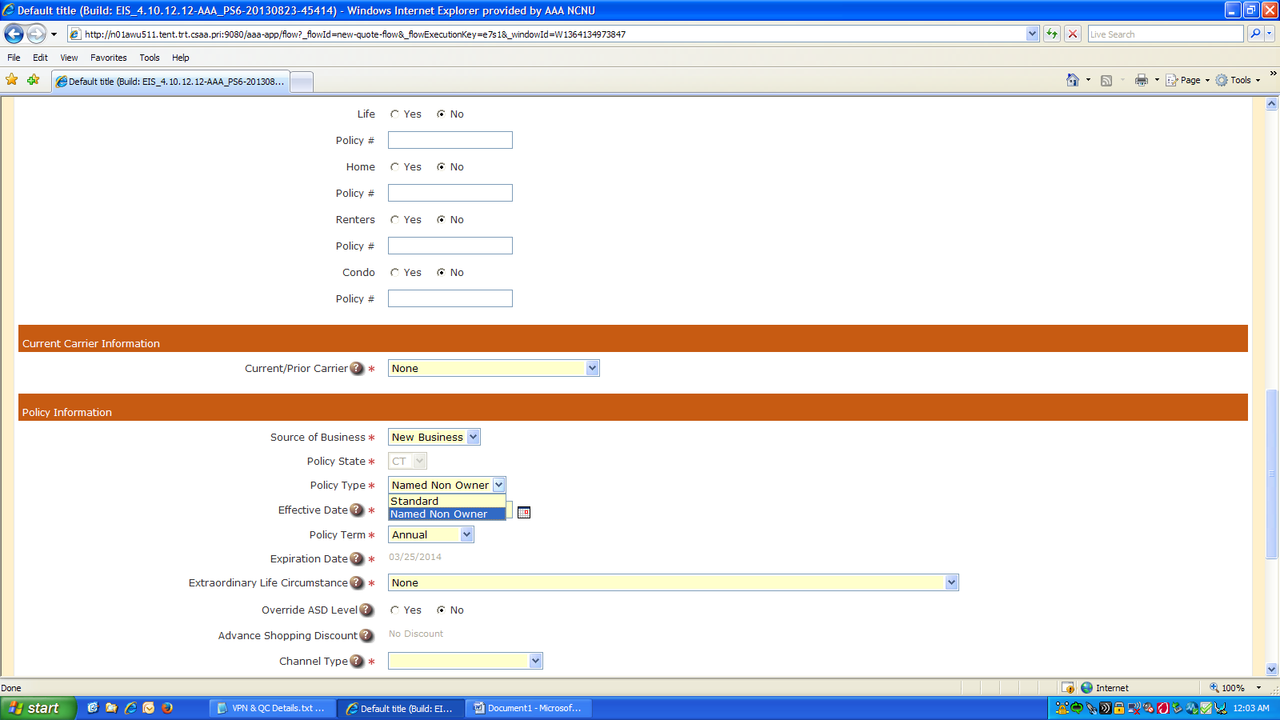

Vehicle page showing the options

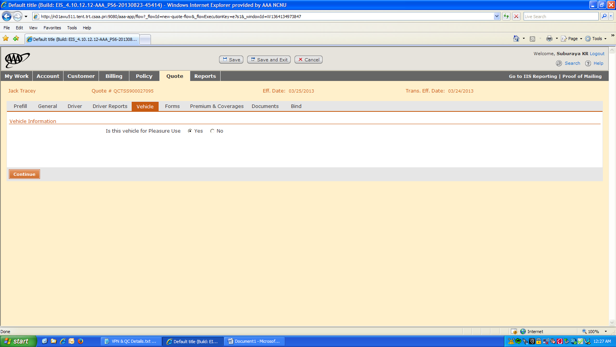

Error message displayed when “No” is selected”

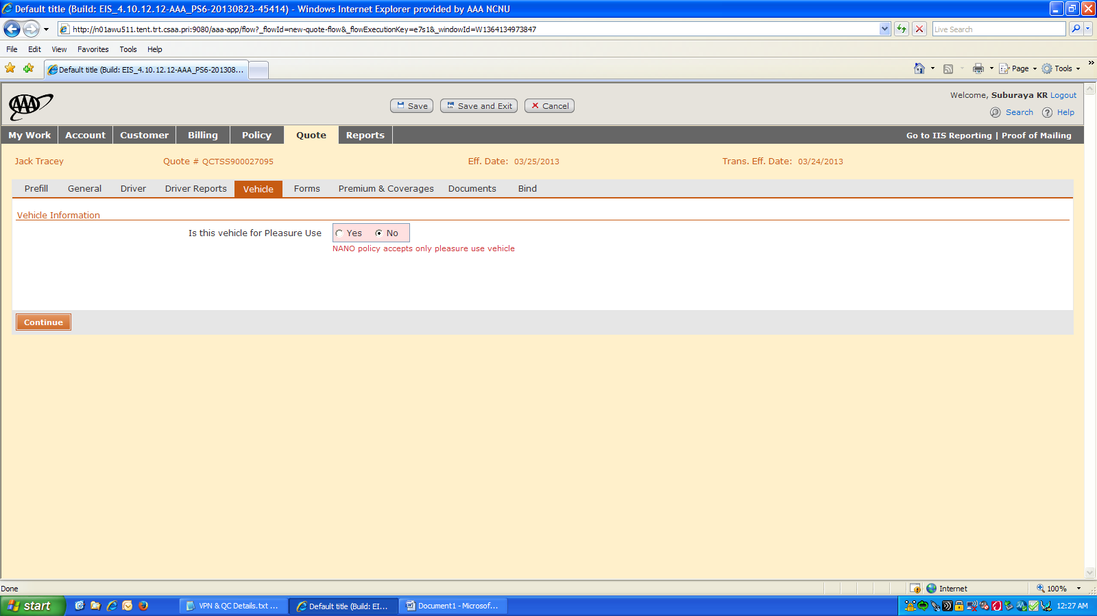

Message displayed when changing Policy Type from “Standard” to “Named Non-Owner”

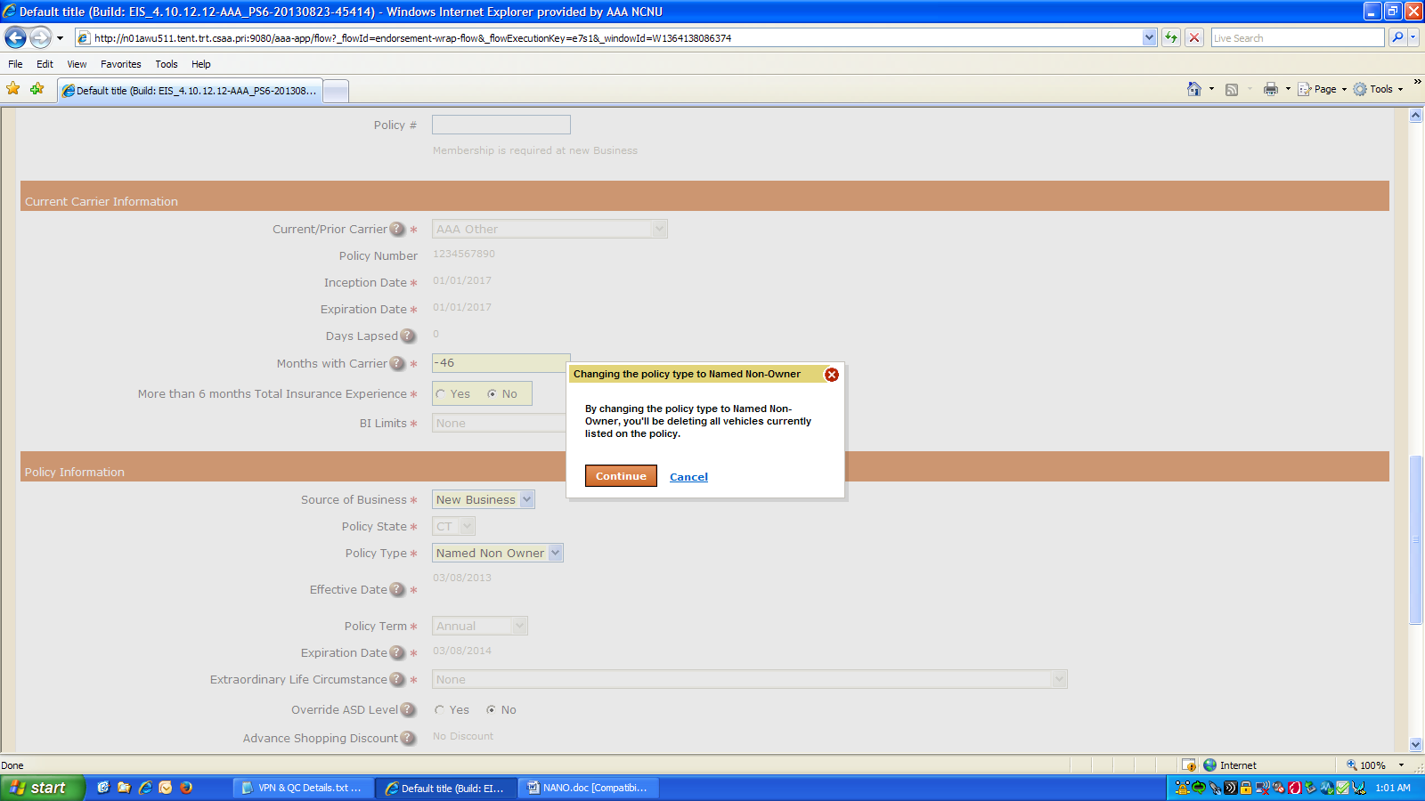

About Deloitte

Deloitte provides audit, tax, consulting, and financial advisory services to public and private clients spanning multiple industries. With a globally connected network of member firms in 140 countries, Deloitte brings world-class capabilities and deep local expertise to help clients succeed wherever they operate. Deloitte's 165,000 professionals are committed to becoming the standard of excellence.

Deloitte's professionals are unified by a collaborative culture that fosters integrity, outstanding value to markets and clients, commitment to each other, and strength from cultural diversity. They enjoy an environment of continuous learning, challenging experiences, and enriching career opportunities. Deloitte's professionals are dedicated to strengthening corporate responsibility, building public trust, and making a positive impact in their communities.

Deloitte refers to one or more of Deloitte Touche Tohmatsu, a Swiss Verein, and its network of member firms, each of which is a legally separate and independent entity. Please see www.deloitte.com/about for a detailed description of the legal structure of Deloitte Touche Tohmatsu and its member firms. Please see <http://www.deloitte.com/us/about> for a detailed description of the legal structure of Deloitte LLP and its subsidiaries.

Internal Usage Statement

This publication is for internal distribution and use only among personnel of Deloitte Touche Tohmatsu, its member firms, and its and their affiliates. Deloitte Touche Tohmatsu, its member firms, and its and their affiliates shall not be responsible for any loss whatsoever sustained by any person who relies on this publication.

Copyright © 2013 Deloitte Development LLC. All rights reserved.

Member of Deloitte Touche Tohmatsu